- Bluebook Page43 May 2019 Variant One examination:

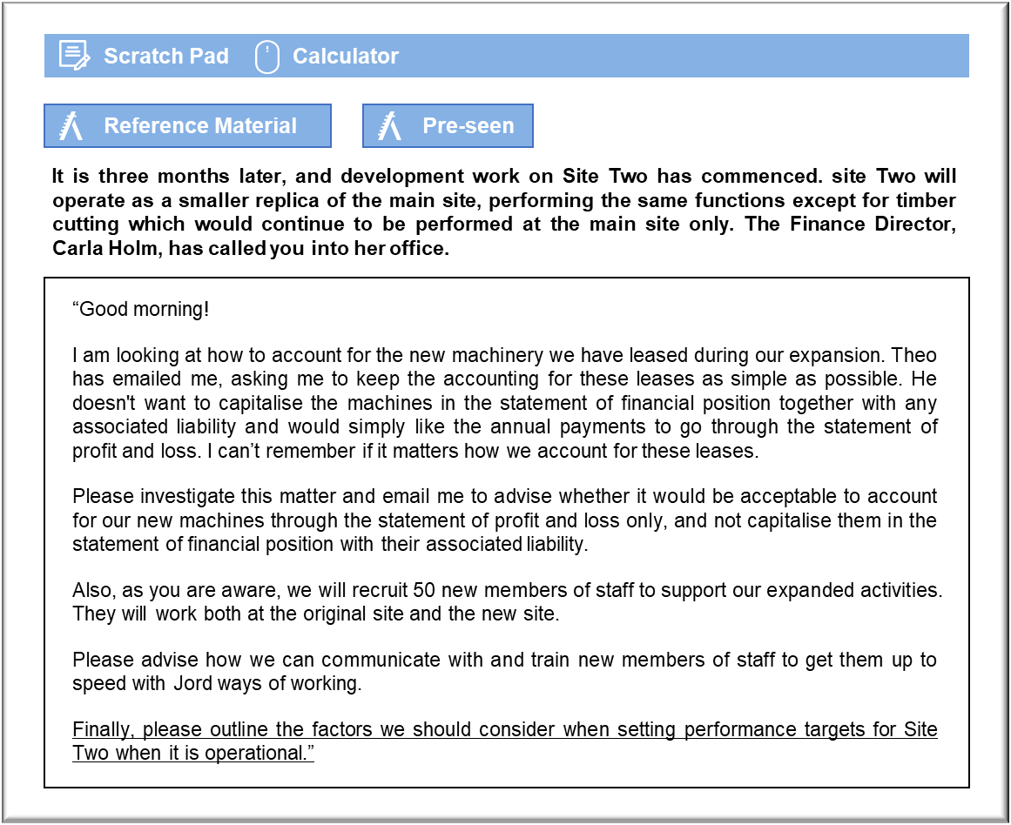

MANAGEMENT CASE STUDY MAY 2019 EXAM ANSWERS

Variant1 Task4
These answers have been provided by CIMA for information purposes only. The answers created are indicative of a response that could be given by a good candidate. They are not to be considered exhaustive, and other appropriate relevant responses would receive credit.

CIMA will not accept challenges to these answers on the basis of academic judgement.

The need to capitalise the leased assets in the statement of financial position, along
with their associated liability, is governed by IFRS 16 Leases, which came into force for
accounting periods beginning on or after 1 January 2019, which makes it relevant to
Jord.
IFRS 16 requires that leases be accounted for on the basis of their economic substance
rather than their legal form. Jord will not own these assets in a legal sense, but it will
control them for the duration of the lease. IFRS 16 requires that the present value of
the future lease payments be calculated at the start of the lease and for the present
value to be capitalised as an asset and a liability. The asset will appear under PPE and
the liability will be split between current and non-current liabilities, depending on
whether they are due within or after 12 months.
Unlike previous standards, IFRS 16 does not permit any discretion over the
interpretation of the lease agreement. The fact that a lease has been signed requires
that the value of the lease should be capitalised, with the asset being depreciated over
the shorter of the lease term and the asset’s useful life. The liability will be adjusted for
the lease payments and the interest accruing on the liability. The categorical treatment
of all leases in the same manner is due to the need to eliminate opportunities for the
distortion of the financial statements through creative accounting. Historically, leases
have been misclassified by some companies who wished to minimise their gearing
ratios. Indeed, financial institutions have developed lease in the past that were
designed to enable companies to manipulate their financial statements and understate
their gearing.
If Jord could be permitted to have the lease flow through the statement of profit or
loss, as Theo wishes, then the shareholders could be misled as to the company’s true
financial position. The future lease payments would be just as much a commitment as
the future payments of capital and interest on a loan. Excluding the present value of
the payments from the statement of financial position would create the impression of a
lean and efficient enterprise, with little in the way of either PPE or debt.
Communication with and training of new staff
The new members of staff will represent around 15% of our overall workforce. It is
important, therefore, that we bring them on board as efficiently as possible, to
minimise the settling down process. It will be important to get new staff up to speed
quickly with Jord ways of working to ensure the costs are managed and our production
schedules are not jeopardised.
A programme should be devised to train new staff, and those members of staff involved
in administering the training should be informed of the timings and the nature of what
is required. Existing staff will be useful to help train the new workforce, and techniques
such as mentoring and teaching whilst on the job will be effective. However, we haven’t
conducted a training programme of this size before so our human resources director,
Eva Edberg, will play a key role in identifying and scheduling the training required and
obtaining additional training resource where necessary. Eva will work with the finance
department to ensure that is run to budget and implemented smoothly.
Good communication throughout the process will be critical and presentations, team
meetings and communication of information by email will all be useful mechanisms to
ensure that staff have the information that they need, when they need it. It is
May 2019 9 Management Case Study Exam
important to create an atmosphere where staff feel comfortable asking questions, so
ensuring the people at the top and the people responsible for training new staff are
approachable and helpful is an essential part of the process.
Performance targets
Although Jord is likely to want to use the same or similar performance measures after
expansion, it is unlikely it would be optimal to use the same targets in the short-term
and if they do this could cause some demotivation amongst staff.
Efficiency levels are likely to drop in the short-term as people get used to working at
the new higher production levels. There will be new members of staff to train and they
cannot all be expected to reach Jord’s high standards of effective working immediately.
Both new and old members of staff will be discouraged if no account is taken of the
changing circumstances in the targets they are working to meet.
Some operations may also be adversely affected by the fact that we are now working
across two sites. For instance, timber cutting only occurs at one site meaning that
transportation between the two sites must be scheduled into workflows. It will be
necessary to increase the standard cycle time for the process being completed from
start to finish to take account of the movement of timber and other changes arising
when two sites are operational. Failure to include these changes make the old targets
unrealistic and therefore potentially ineffective drivers for staff.
It seems sensible to look again at targets provided to staff, adjusting for the anticipated
changes in short term efficiency. We may even want to put in place some different
performance measures from those currently used to encourage smooth transition to
higher levels of production.
Hopefully, then, in the long term, as Jord staff benefit from the learning curve effect,
things will return to a state that is as efficient as before and we may well find that
targets can return to their pre-expansion level once things have settled down.
If Jord takes no account of the new working situation and keeps efficiency and waste
targets at the same levels as they were before expansion there could be a significant
impact on morale which would further increase the challenges faced in this time of
change..

